Electric Spray Gun
SG550
GB

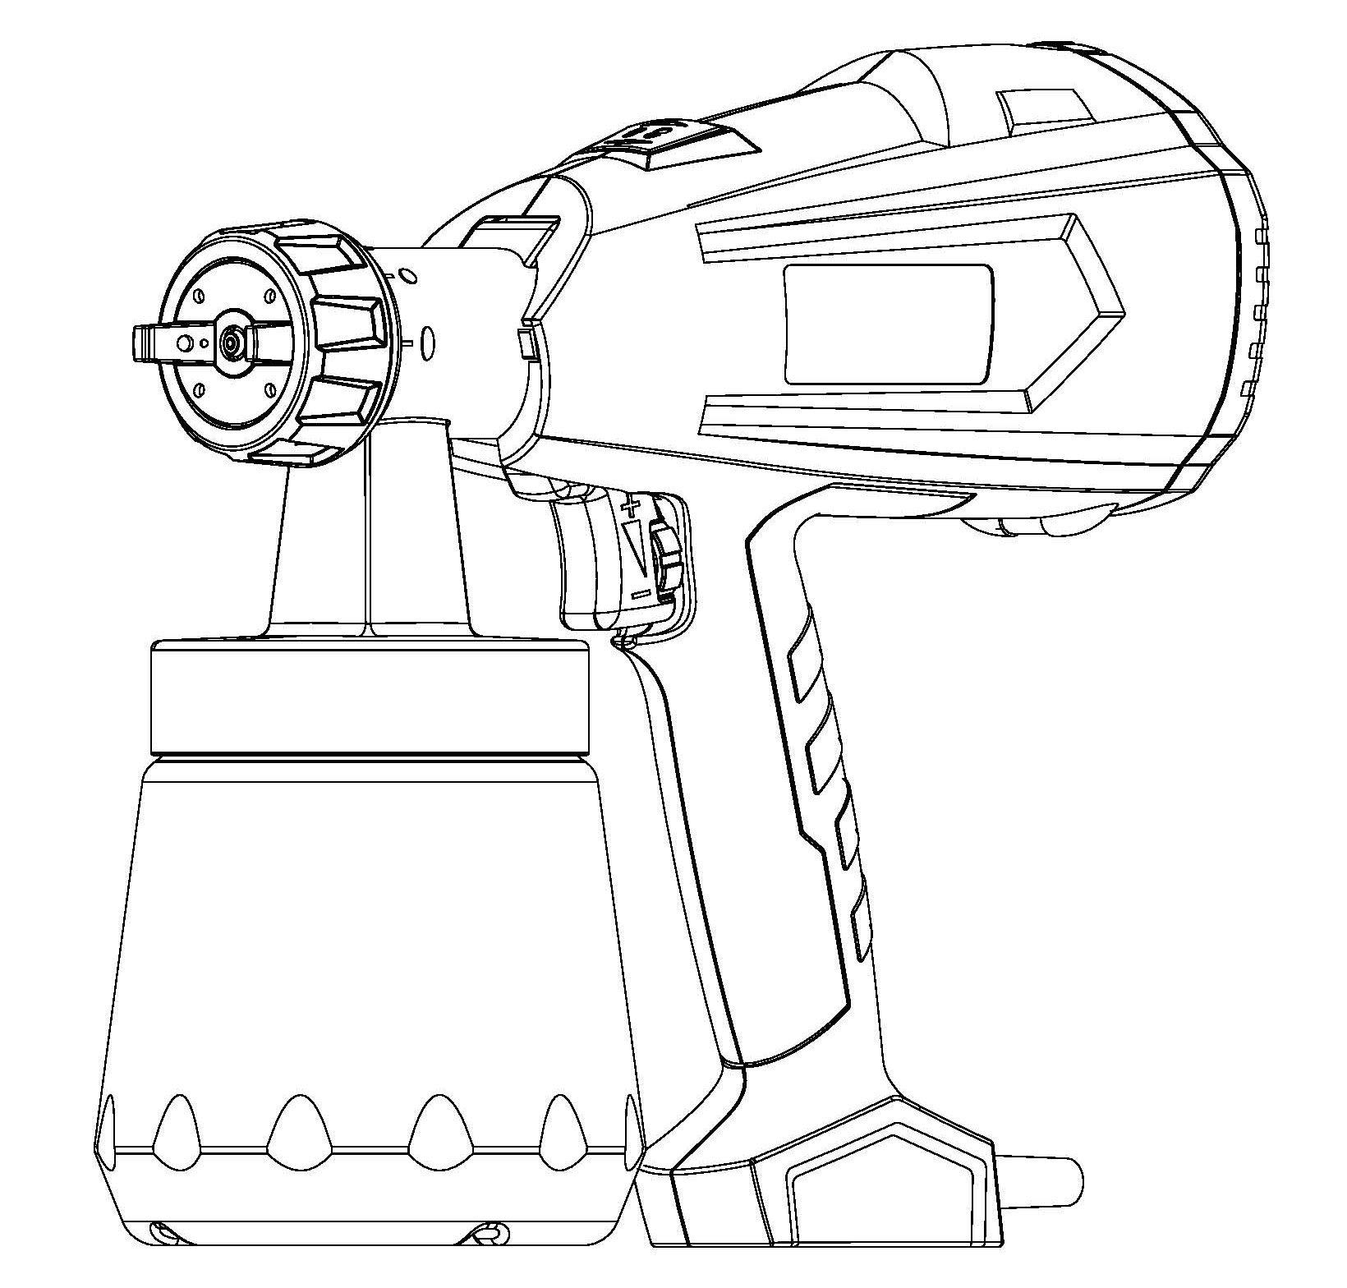

GB

Read this operators guide carefully, before using the machine. Ensure that you know how the machine works, and how it should be operated. Maintain the machine in accordance with the instructions, and make certain that the machine functions correctly. Keep this operator’s guide and other enclosed documentation with the machine.

TECHNICAL SPECIFICATIONS

Model | SG550
Max. viscosity | 60 DIN-s
Rated voltage | 220-240 V ~ 50/60Hz
Rated input power | 550W
Double insulation | 回
Container capacity | 800mL
Flow rate | Nozzle size | Flow rate
Flow rate | Φ1.8 mm | 300ml/min
Flow rate | Φ2.6 mm | 800ml/min
Sound pressure level L_{PA} | 76.13dB(A)
 | K=3dB(A)
Sound power level L_{WA} | 87.13dB(A)
 | K=3dB(A)
Vibration emission | <2.5 m/s2, K=1.5 m/s2
Net weight | 1.25KG

Over view

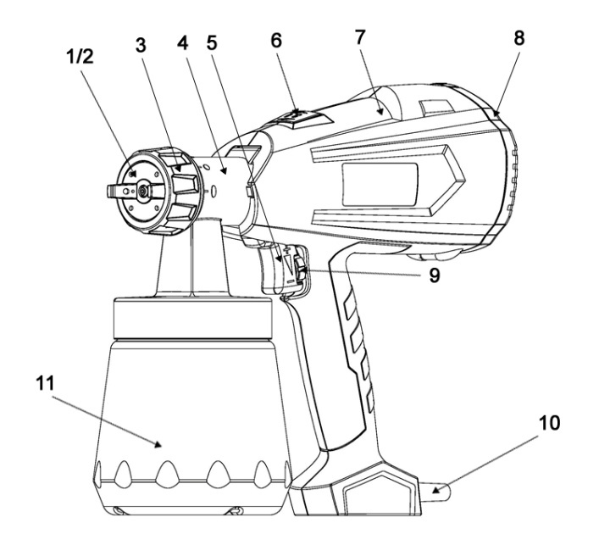
1) Air Cap | 2) Nozzle
3) Union nut | 4) Spray gun front part
5) Trigger guard | 6) unlock button
7) Spray gun rear part | 8) Air filter cover
9) Material volume adjustment | 10) Mains lead
11) Container

General Safety Instructions for Electric Tools

WARNING. When using electric tools, basic safety precautions, including the following, should always be followed to reduce the risk of fire, electric shock and personal injury.
Read all these instructions before operating this product and save these instruction.
For safe operations:
1) Keep work area clean
-- Cluttered areas and benches invite injuries.
2) Consider work area environment.
-- Do not expose power tools to rain. Do not use power tools in damp or wet locations. keep work area well lit. Do not use power tools where there is risk to cause fire or explosion.
3) Guard against electric shock.
-- Avoid body contact with earthed or grounded surfaces (e.g. pipes, radiators, ranges, refrigerators).
4) Keep children away.
-- Do not let visitors touch the tool or extension visitors should be kept away from area.
5) Store idle tools.
-- When not in use, tools should be stored in a dry, high or locked up place, out of reach of children.
6) Dc not forces the tool.
-- It will do the job better and safer at the rate for which it was intended.
7) Use the right mol.
-- Do not force small tools or attachments to do the job of a heavy duty tool. Do not use tools for purposes not intended; for example, do not use circular saws to cut tree limbs or logs.
8) Dress properly.
-- Do not wear loose clothing or jewelers; they can be caught in moving parts. Rubber gloves and non-skid footwear are recommended when working out doors. Wear protecting hair covering to contain long hair.
9) Use safety glasses.
10) Connect dust extraction equipment.
-- If devices are provided for the connection of dust extraction and collection facilities ensure these are connected and properly used.
11) Do not abuse the cord.
-- Never carry the tool by the cord or yank it to disconnect it from the socket, Keep the cord away from heat, oil and sharp edges.
12) Secure work.
-- Use clamps or a vice to hold the work. It is safer than using your hand and it frees both hands to operate the tool.
13) Do not overreach.
-- Keep proper footing and balance at all times
14) Maintain tool with care.
-- Keep cutting tools sharp and clean for better and safer performance. Follow instructions for lubrication and changing accessories, inspect tool cord periodically and if damaged have it repaired by an authorized service facility. Inspect extension cords periodically and replace, if damaged. Keep handles dry, clean and free from oil and grease
15) Disconnect tools.
-- When not in use, before servicing and when changing accessories such as blades, bits and cutters.
16) Remove adjusting keys and wrenches.
-- Form the habit of checking to see that keys and adjusting wrenches are removed from the tool before turning it on.
17) Alvord unintentional starting.
-- Do not carry a plugged-in toot with a finger on the switch. Ensure switch, is off when plugging in.
18) Use outdoor extension leads.
- When tool is used outdoors, use only extension cords intended for outdoor use.
19) Stay alert.
-- Watch what you are doing, Use common sense. Do not operate tool when you are tired.
20) Check damaged parts.
-- Better further use of the tool, a guard or other part that is damaged should be carefully checked to determine that it would operate properly and perform its intended function. Check for alignment of moving parts, free running of moving parts, breakage of parts, mounting and any other conditions that may affect its operational. A guard or other part char is damaged could be properly repaired or replaced by an authorized service center unless otherwise indicated in this instruction manual. Have defective switches replaced by an authorized service facility. Do not use the tool if the switch does not turn it on and off.
21) Warning.
--The use of any accessory or attachment, other than those recommended, in this instruction manual, may present a risk of personal injury.
22) Have your tool repaired by a qualified person.
-- This electric tool is in accordance with the relevant safety requirements. Repairs should only be carried out by qualified persons using original spare parts, otherwise this may result in considerable danger to the user.
Safety Instructions for Spray Guns
- You may only spray coating materials such as paints, varnishes, glazes, etc. with a point of 21°C (32°C in UK) and higher without additional warning.
- The device may not be used in workplaces covered by the explosion-protection regulations.
- There must be no sources of ignition such as, for example, smoke of cigarettes, cigars and tobacco pipes, sparks, glowing wires, hot surfaces, etc. in the vicinity during spraying.
- Do not spray any substances whose hazard potential is not known.
- Before working on the spray gun remove the power plug from the socket.
- Do not use the spray guns to spray flammable substances.
- The spray guns are not to be cleaned with flammable solvents which have a flash point under 21°C.
- Caution against dangers that can arise from the sprayed substance and observe the text and information on the containers or the specifications given by the substance manufacturer.

Recommendation: Wear a breathing mask and safety glasses when spraying.

CAUTION - DANGER OF INJURY!

Never point the spray gun at yourself, at other people or at animals.

- When working with the tool indoors as well as outdoors ensure that no solvent vapors are sucked in by the spray gun.
- When working outdoors, be aware of the wind direction. Wind can carry the coating substance across greater distances - thus causing damage. When working indoors, provide for adequate ventilation.
- Do not let children handle the device.
- Never open the device yourself in order to carry out repairs in the electrical system!
- Do not lay the spray gun.
Residual risks
Even when the power tool is used as prescribed it is not possible to eliminate all residual risk factors. The following hazards may arise in connection with the power tool’s construction and design:
- Damage to lungs if an effective dust mask is not worn.
- Damage to hearing if effective hearing protection is not worn.
- Damages to health resulting from vibration emission if the power tool is being used over longer period of time or not adequately managed and properly maintained.

WARNING! This power tool produces an electromagnetic field during operation. This field may under some circumstances interfere with active or passive medical implants. To reduce the risk of serious or fatal injury, we recommend persons with medical implants to consult their physician and the medical implant manufacturer before operating this machine.

OPERATION INSTRUCTIONS

Wear hearing protection while operating the power tool.
The declared vibration total value has been measured in accordance with a standard test method and may be used for comparing one tool with another.
The declared vibration total value may also be used in a preliminary assessment of exposure.
Warning
The vibration emission during actual use of the power tool can differ from the declared total value depending on the ways in which the tool is used.
There is the need to identify safety measures to protect the operator that are based on an estimation of exposure in the actual conditions of use (taking account of all parts of the operating cycle such as the times when the tool is switched off and when it is running idle in addition to the trigger time).

Coating Materials Suitable for Use

Water- and solvent-based paints, fnishes, primers, 2-component paints, clear fnishes, automotive finishes, staining sealers and wood sealer-preservatives.

Coating Materials Not Suitable for Use

Wall paints (emulsion paints) etc., alkali and acidic paints. Coating materials with a frash point below 21°C.

Preparation of the Coating Material
The enclosed spray attachment can be used to spray paints, varnishes and glazes that are undiluted or slightly diluted.
- Stir the material up and put the required amount into the paint container

Thinning recommendation
Sprayed material
Glazes | undiluted
Wood preservatives, mordants, oils, disinfection agents, plant protective agents | undiluted
Paints containing solvents and water-soluble  paints, primers, vehicle coating paints,  hick-flm glazes | dilute by 5 - 10%

- If the convey capacity is too low, add 5 - 10% dilution step-by-step until the convey capacity fulfills your requirements.

B
A

- 1
Start-up
Before connecting to the mains supply, be sure that the supply voltage is identical with the value given on the rating plate.
- Unscrew the container from the spray gun.
- Aligning suction tube. (Fig. 2)
If the suction tube is positioned correctly, the container contents can be sprayed without almost any residue.
When working on lying objects: Turn the suction tube forwards. (Fig. 2 A)
Spraying work when working on overhead objects: Turn the suction tube rearwards. (Fig. 2 B)

- Set the container on a sheet of paper, pour in the prepared coating material and screw the container tightly onto the spray gun.
- Put the machine down only on a level, clean surface. Otherwise the machine could tip over!
- Adjust the spray setting on the spray gun.

Three different spray jet settings can be chosen on the spray gun, depending on theapplication and target object.
Selecting the Spray Setting
Fig. 3 A = horizontal fat jet →
Fig. 3 B = circular jet →
Fig. 3 C = vertical fat jet →
The spray pattern indication can be found on the front part of the sprayer. With the arrowhead towards the boss on the tip.
Boss on the tip
Spray pattern indicator

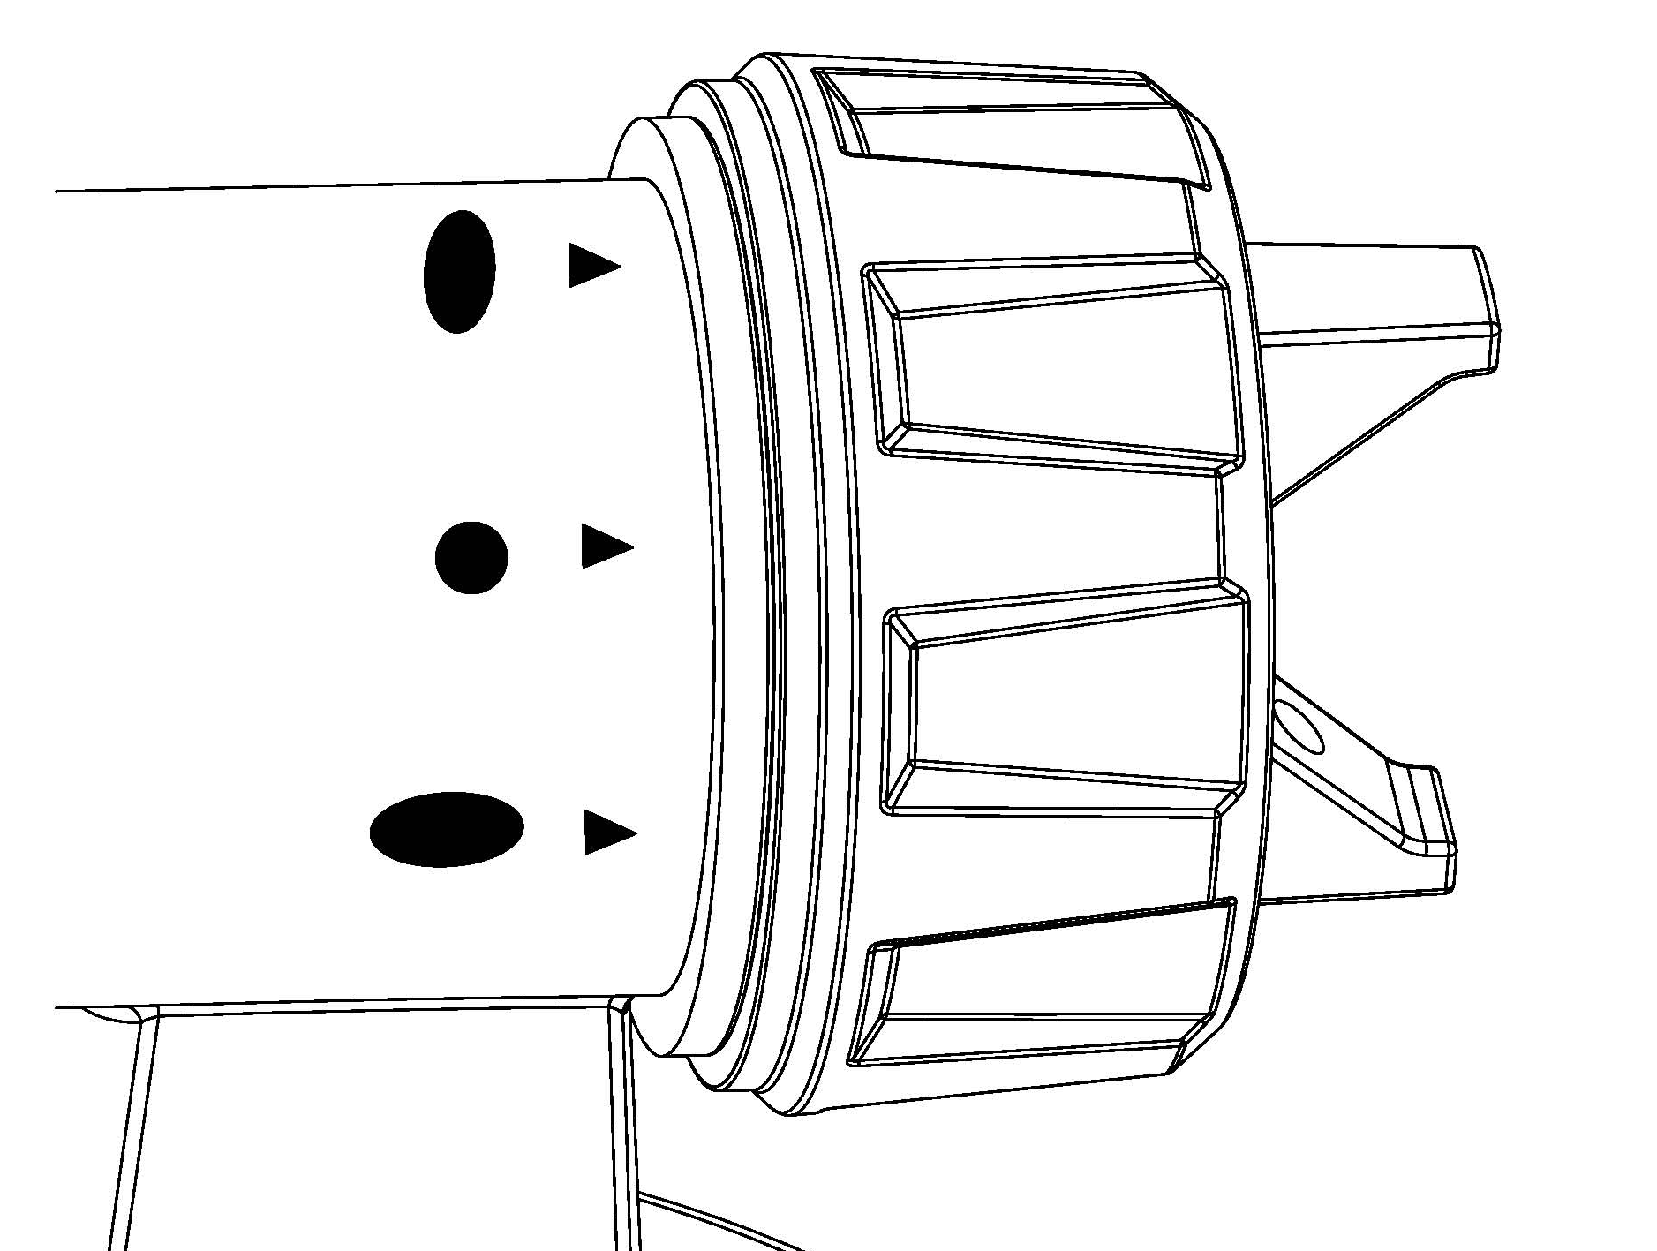

Adjusting the desired Spray Setting (Fig. 4)
With the union nut (2) slightly unscrewed, turn the air cap (1) to the desired spray setting position. Then tighten the union nut.
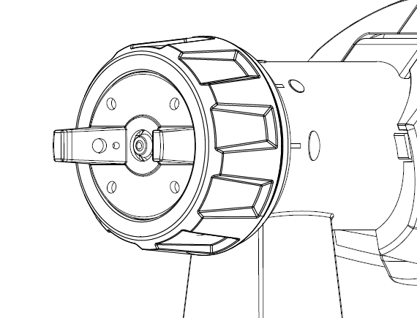Fig. 4

WARNING! Danger of injury! Never pull the trigger guard while adjusting the air cap.

Adjusting the Material Volume (Fig. 5)
Set the material volume by turning the regulator on the trigger guard of the spray gun.
- turn to downside → lower material volume
+ turn to upside → higher material volume
Spray Technique
- The spray result depends heavily on the smoothness and cleanliness of the surface to be sprayed. Therefore the surface should be carefully prepared and kept free of dust.
- Cover all surfaces not to be sprayed.
- Cover screw threads or similar parts of the target object.
- It is advisable to test the spray gun on cardboard or a similar surface to find the correct setting.
Important: Begin spraying outside of the target area and avoid interruptions inside the target area.

- Correct (Fig. 6a). Be sure to hold the spray gun at an even distance of approx. 10 – 30 cm to the target object.
- Incorrect (Fig. 6b) Heavy spray fog build-up, uneven surface quality.
- Move the spray gun evenly cross-wise or up-and-down, depending on the spray pattern setting.
- An even movement of the spray gun results in an even surface quality.
- When coating material builds up on the nozzle (A) and air cap (B) (Fig. 7), clean both parts
with a solvent or water.

Fig.7
B
A

Taking Out of Operation and Cleaning
Proper cleaning is the prerequisite for problem-free operation of the paint application device. No warranty claims are accepted in case of improper or no cleaning.
1) Unplug the power plug. Vent the container in case of longer breaks and after the work has been terminated. This can be done by briefly turning open and then closing the container or by pulling the trigger guard and letting the paint into the original paint container.
2) Divide the spray gun. Press the unlock button (Fig. 8) downwards.
3) Unscrew the container. Empty any remaining coating material back into the material tin.
4) Preclean the container and suction tube with a brush.
5) Pour solvent or water into the container. Screw the container back on. Use only solvents with a flashpoint over 21°C .
6) Assemble the gun again.
7) Insert the power plug, turn on the machine and spray the solvent or water into a container or a cloth.
8) Repeat the above procedure until the solvent or water emerging from the nozzle is clear.
9) Turn of the machine and remove the plug.
CAUTION!
Never clean seals, diaphragm and nozzle or air holes of the spray gun with metal objects.
The ventilation hose and diaphragm are only solvent-resistant to a limited extent. Do not immerse in solvent, only wipe.

WARNING! Never hold the spray gun rear part under water or immerse it into liquids. Clean the housing only with a moistened cloth.

10) clean the outside of the spray gun and container with a cloth soaked in solvent or water.
11) Unscrew the union nut and remove the air cap and nozzle. Clean the air cap and nozzle with a brush and solvent or water.

Unlock button
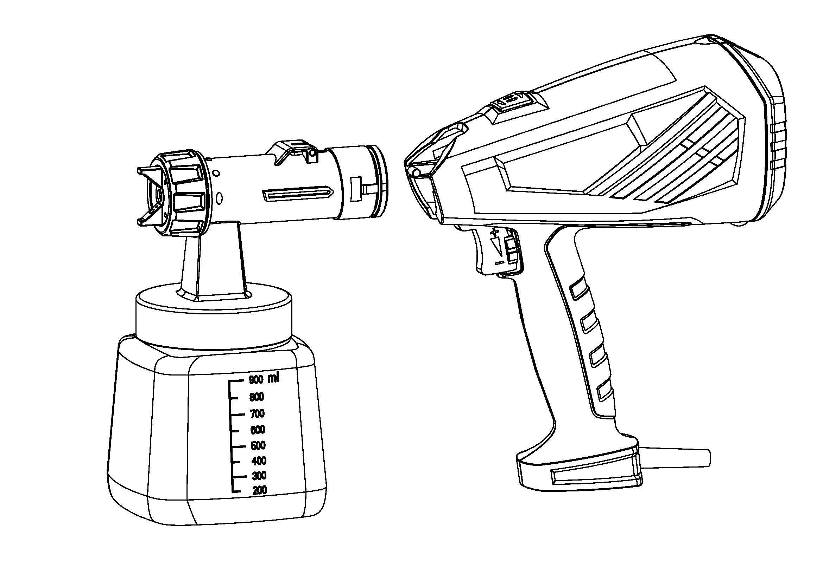
Fig.8

Maintenance
Change the air filter if it is soiled (Fig. 9, item 7).
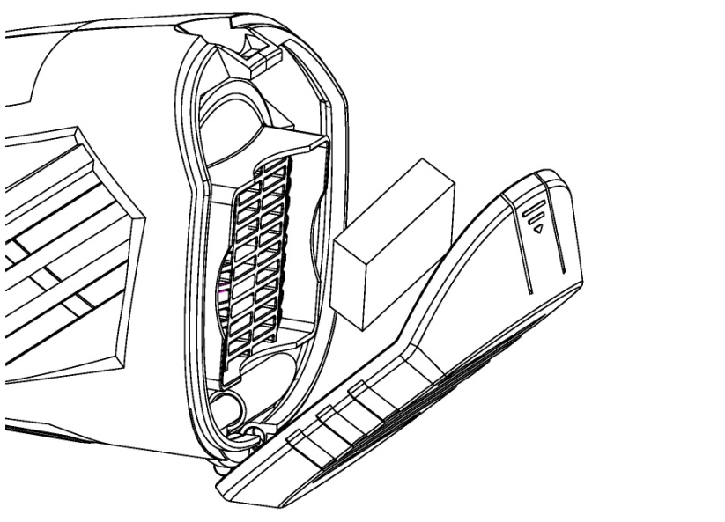
7, air filter
Fig. 9

WARNING! Never operate the machine without the air filter; dirt could be sucked in and interfere with the function of the machine.

Correction of Malfunctions
Problem | Cause | Remedy
No coating material emerges from the nozzle | Nozzle clogged  Feed tube clogged  Material volume setting turned too far to the left (-)  Feed tube loose  No pressure build-up in container | Clean  Clean  Turn to the right (+)  Insert  Tighten container
Coating material drips  from the nozzle | Nozzle loose  Nozzle worn  Nozzle seal worn  Coating material assembly at air cap, nozzle or needle | Tighten  Change  Change  Clean
Atomisation too coarse | Viscosity of coating material too high  Material volume too large  Material volume adjusting screw turned  too far to the right (+)  Nozzle contaminated  Air filter heavily soiled  Too little pressure build-up in container | Thin  Turn material volume adjusting  screw to the left (-)  Clean  Change  Tighten container
Spray jet pulsates | Coating material in container running out  Air filter heavily soiled | Refill  Change
Coating material causes "paint tears" | Too much coating material applied. | Turn material volume adjusting screw to the left (-)
Too much fog of  coating material  (Overspray) | Distance to the object too large  Too much coating material applied | Reduce distance Turn material volume adjusting screw to the left (-)
Painting the ventilating hose | Diaphragm soiled  Diaphragm defective | Clean the diaphragm  Replace the diaphragm
Environmental protection

The appliance and accessories should be recycled in an environmentally friendly way. Do not dispose of the appliance with household waste. Support environmental protection by taking the appliance to a local collection point or obtain information from a specialist retailer.

SG550 exploded view

SG550 part list

